The Ministry of Science and Technology  THE NATIONAL OFFICE OF INTELLECTUAL PROPERTY | 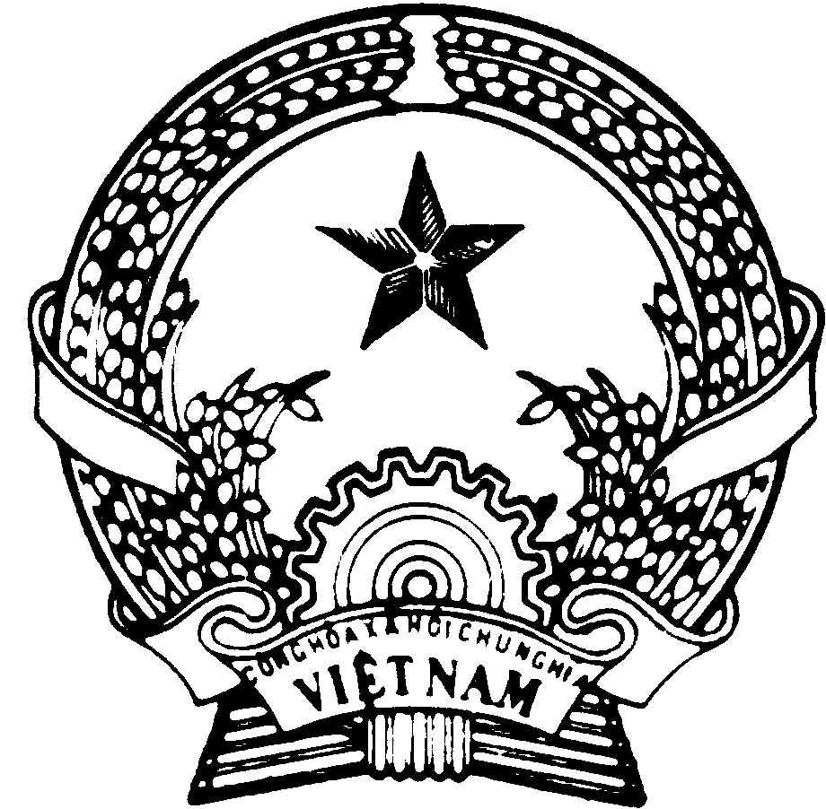 | SOCIALIST REPUBLIC OF VIETNAM  Independent – Freedom – Happiness

CERTIFICATE OF
TRADEMARK REGISTRATION
No.: 27447
(REISSUED VERSION)

Owner of the certificate: MORITA FIRE PUMP MFG. CO., LTD (JP)
5-20, Shoji-higashi 5-chome, Ikuno-ku, Osaka-shi, Osaka-fu, Japan
Application No.: 4-1997-32923 (32923)
Filing Date: February 28, 1997
Granted by Decision No.: 1452/QDNH, date: June 27, 1998
Having validity from the granting date to the expiration of a period of 10 years counted from the filing date (renewable).
Firstly reissued pursuant to the Decision of Reissue No.: 353/QD-DK, date: November 27, 2006

VN 4-0027447 | PP. DIRECTOR  VICE DIRECTOR  (signed and sealed)  Tran Viet Hung

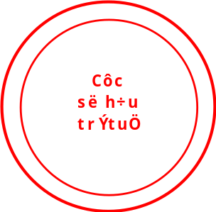
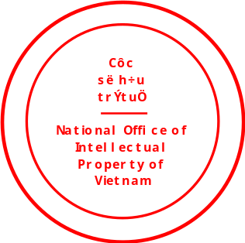

Representation of the trademark:

[sample of the mark]

Colors of the trademark: [colors of the trademark]
Type of the trademark: [type of the trademark]
Other contents: [any other notes stated here]
List of goods/services: [List of goods/services stated here]

Amendment, renewal:

